SKILL-4WEEK
TASK-1 : Process Synchronization and Child Process Monitoring Using waitpid()

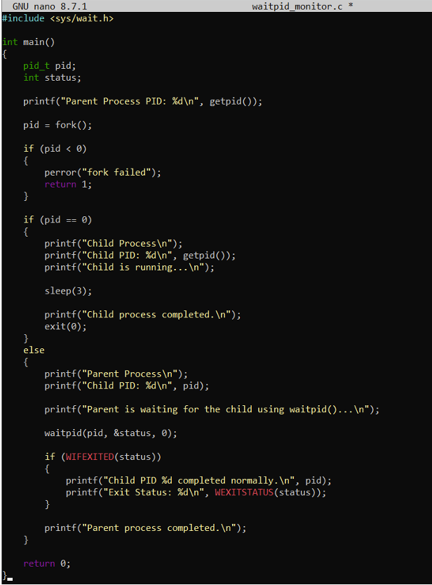

OUTPUT:

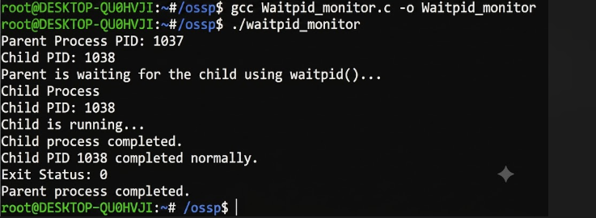

REPORT:
I created a parent and child process using fork() and used waitpid() to synchronize the child process with the parent. From the output, I observed that the parent waited until the child process completed and then checked its exit status. I understood how waitpid() helps the parent monitor and synchronize with a particular child process.
Task-2:
To Retrieve PATH Variable, Parse Search Directories, Locate Executables, Verify Permissions, Handle Missing Commands, Test Command Resolution

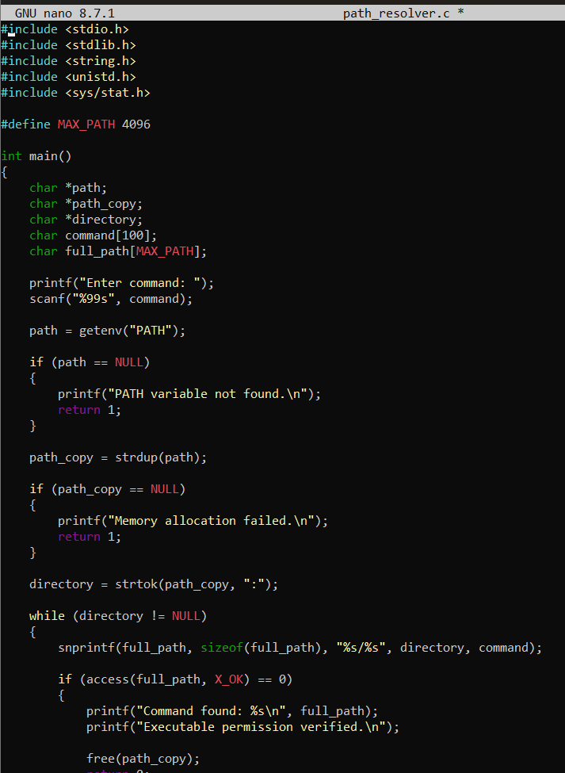

OUTPUT:

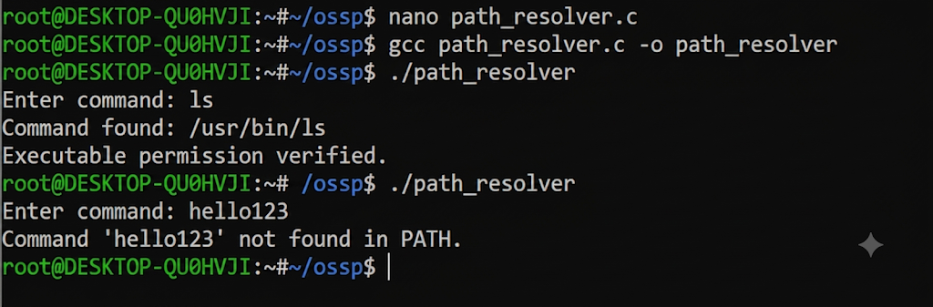

Report:
I implemented a program to search for commands using the PATH environment variable. The program searches the directories in PATH and checks whether the command exists and has executable permission. I tested the program using the ls command and it successfully located the executable. I also tested a missing command to check the error handling. I understood how the shell searches for executable commands using the PATH variable.

Task-3:
To Detect Variable References, Expand Values, Handle Undefined Variables, Update Tokens, Support Nested Variables, Test Expansion Logic

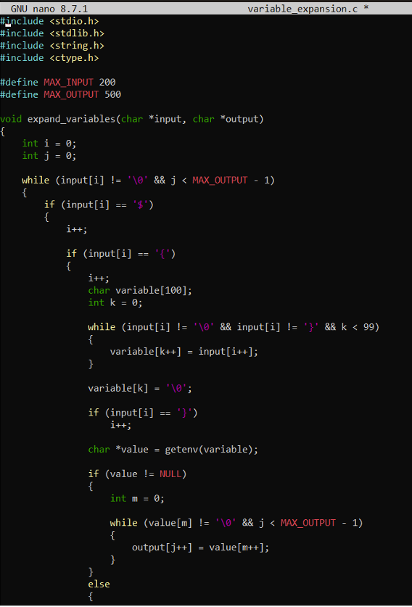

Output:
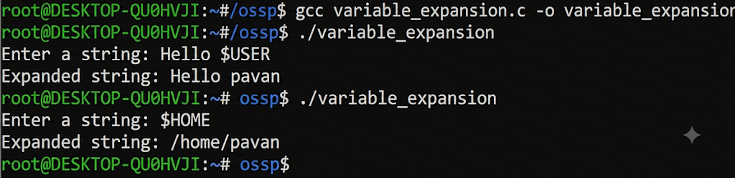

Report:
I implemented variable expansion in the shell by detecting variable references using $ and retrieving their values from the environment. I tested defined and undefined variables and
observed that defined variables are replaced with their actual values, while undefined variables are reported. I understood how environment variables can be expanded and updated in the input string.
To Identify Built-ins, Create Dispatch Table, Execute In-Process Commands, Handle Invalid Commands, Maintain State, Test Dispatch Logical

Task-4:
To Identify Built-ins, Create Dispatch Table, Execute In-Process Commands, Handle Invalid Commands, Maintain State, Test Dispatch Logic

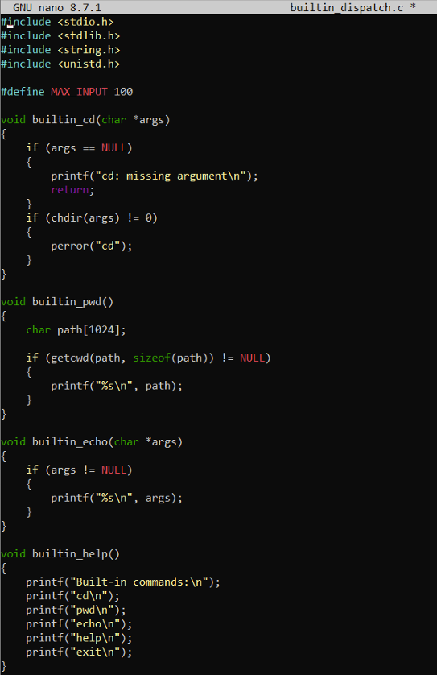

OUTPUT:
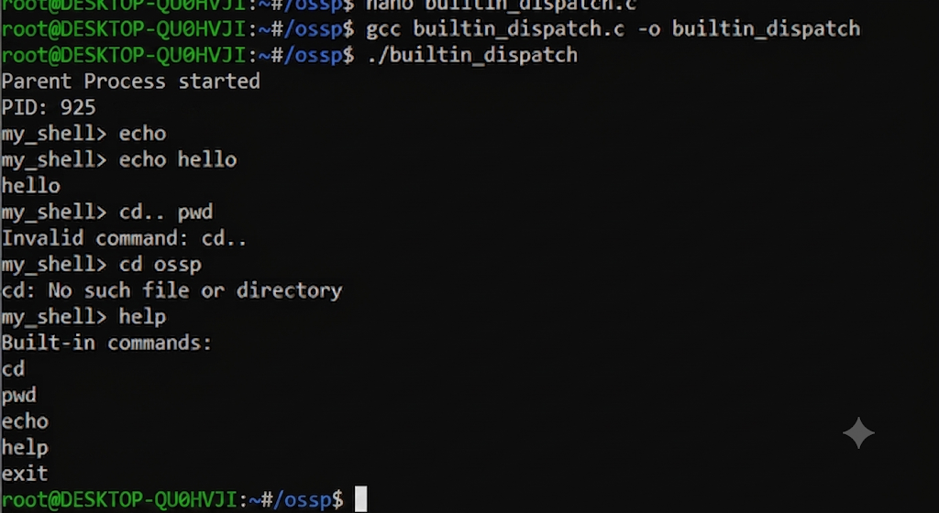

Report:
I implemented a dispatch system for built-in shell commands such as cd, pwd, echo, help, and exit. I tested the commands and also checked an invalid command to verify error handling. I understood that built-in commands are executed within the shell process and that commands like cd can maintain the shell's current state.

